Internship Report
on
TITLE
JAWAHARLAL NEHRU TECHNOLOGICAL UNIVERSITY ANANTAPUR

In Partial Fulfillment of the Requirements for the Award of the degree of

BACHELOR OF TECHNOLOGY
In
COMPUTER SCIENCE AND ENGINEERING (DATA SCIENCE)
Submitted By
Student name - (Roll no)



MADANAPALLE INSTITUTE OF TECHNOLOGY & SCIENCE
(UGC – AUTONOMOUS)
(Affiliated to JNTUA)
(Accredited by NBA, Approved by AICTE, New Delhi)
AN ISO 21001:2018 Certified Institution
P. B. No: 14, Angallu, Madanapalle – 517325
2026 - 2027

2009-2013

DEPARTMENT OF COMPUTER SCIENCE AND ENGINEERING
(DATA SCIENCE)

BONAFIDE CERTIFICATE

This is to certify that the internship work entitled “Project Name” is a bonafide work
carried out by

Student name - (Roll no )

Submitted in partial fulfillment of the requirements for the award of degree Bachelor of Technology in the stream of Computer Science and Engineering (Data Science) in Madanapalle Institute of Technology & Science, Madanapalle, affiliated to Jawaharlal Nehru Technological University Anantapur, Ananthapuramu during the academic year 2025-2026.

Internship Coordinator Head of the Department
Mr. N. Bhargav Krishna, Dr. S. Kusuma,
Assistant Professor, Assistant Professor & Head,
Department of CSE – Data Science Department of CSE – Data Science

ACKNOWLEDGEMENT

I sincerely thank the Management of Madanapalle Institute of Technology & Science for providing excellent infrastructure and lab facilities that helped me complete this Internship.
I sincerely thank Dr. P. Ramanathan, Principal, for guiding and providing facilities for completing our Internship at Madanapalle Institute of Technology & Science, Madanapalle.
I express our gratitude to Dr. S. Kusuma, Assistant Professor and Head, Department of CSE(Data Science) for her continuous support in making necessary arrangements for the successful completion of the Internship.
I express our sincere thanks to the Internship Coordinator, Mr. N. Bhargav Krishna, Assistant Professor, Department of CSE (Data Science) for his tremendous support for the successful completion of Internship.
I also wish to place on record my gratefulness to other Faculty of CSE(Data Science) Department and our friends and our parents for their help and cooperation during our project work.

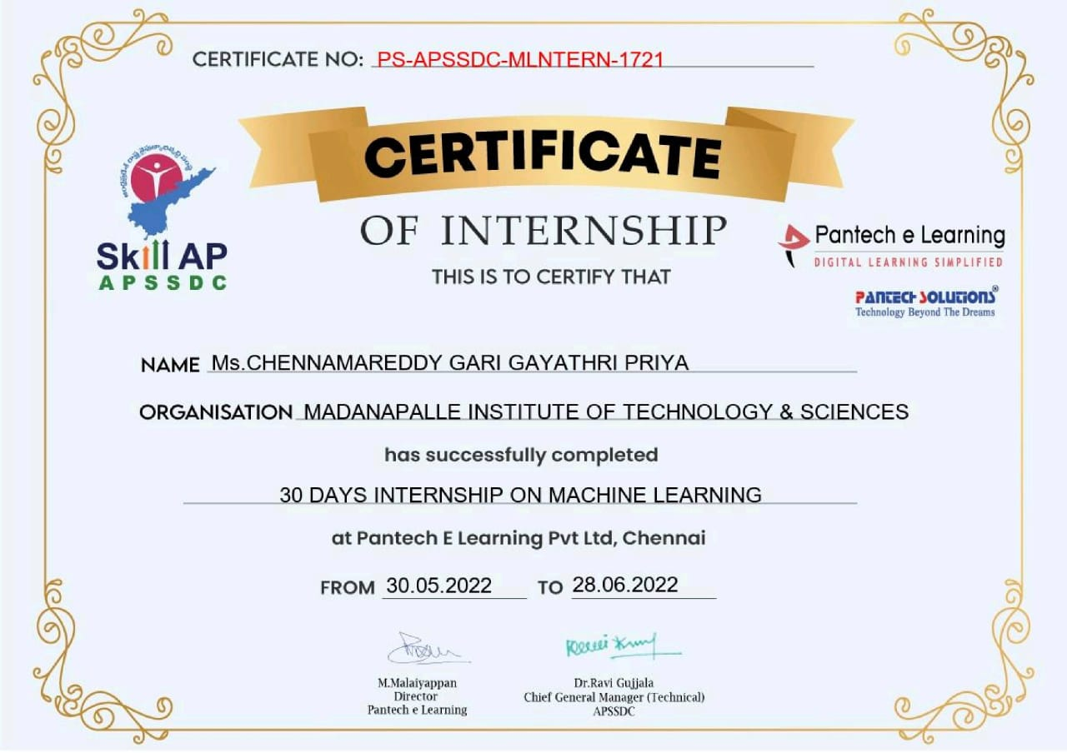

DECLARATION

I hereby declare that the results embodied in this internship "<<Title>>" by me under the guidance of <<mentor name>>, in partial fulfillment of the award of Bachelor of Technology in Computer Science and Engineering (Data Science) from Jawaharlal Nehru Technological University Anantapur, Ananthapuramu.

Place: Madanapalle Name :

Date: Roll No.:

Department of CSE(DS)

Madanapalle Institute of Technology & Science Madanapalle.

ABSTRACT
[Entire body of the text should be Times New Roman font with 12 pt size, and alignment should be “justify”]
Machine Learning is one of the emerging fields of Artificial Intelligence and it has many applications. It is a tool that uses data and Artificial Intelligence in its areas of application. The main idea behind the development of machine learning algorithms is to create a model that understands and analyzes the given data and helps in prediction. Machine learning methods can be applied to various domains.
With the increase in growth of technology, stress and anxiety in an individual are also increasing. Stress is invisible and it’s like a slow poison. Stress, tension, and anxiety are the features that could compromise the psychological wellness of individuals. These factors could lead an individual to take their own lives. Therefore, it is important for any person to manage stress, to live a healthy and a balanced life. Many organizations including our government are trying to find the people under stress and get them treated. This can be achieved if there is a machine that can detect stress by understanding texts from posts. The main objective of this project is to create a stress detection machine. The rise of social media is changing people’s life. Now-a-days, with the growing popularity of social media, people are sharing their activities, moods and interactions through the social media posts. If we know whether the person is under stress or not, then we can treat them accordingly. Because, there might be some words that can trigger some sort of anxiety in the people under stress. The main objective of this project is to identify such people through their posts or blogs. The machine reads the posts and detects whether the person is under stress or not.
In the internship I have done on Machine Learning, I did a project on Stress detection. The goal of the project was to create a model to input text from the user and return whether the person is under stress or not. In order to analyze the human language, recognition is not enough so we use natural language processing. For example, if we write “I’m happy” in the input box, since the state you are expressing indicates that you are not under stress then the model should return ‘No stress’. And if the input given is “I need some help”, then the output should be ‘Stress’.

Keywords: Artificial intelligence, Natural Language Processing

CONTENTS
CHAPTER Page No.
1. INTRODUCTION……………………………………………………………………. [#]
1.1. Problem Statement [#]
1.2. Objectives [#]
1.3. Domain Technology [#]
1.4. Industry Vertical [#]
1.5. Data [#]
1.6. Purpose [#]
1.7. Methods [#]
2. HARDWARE AND SOFTWARE.………...……………………………………. [#]
2.1. Platform Used [#]
2.2. Hardware Requirements [#]
2.3 Software Requirements [#]
3. PROJECT ANALYSIS……………….….…………………………………….……. [#]
3.1. Architecture Diagram [#]
3.2. Algorithm / Techniques [#]
3.2.1 Algorithm
3.3. Implementation [#]
3.4. Results [#]

4. CONCLUSION………………..………………………………………….……….……. [#] 5. APPENDICES …………..………………………………………………………….……. [#]
A- SOURCE CODE [#]
B -SCREEN SHOTS [#]
6. REFERENCES

CHAPTER-1 INTRODUCTION
  - PROBLEM STATEMENT:
With the growing demand for scalable computing resources, organizations increasingly rely on cloud bursting — a hybrid cloud strategy that allows applications to dynamically extend workloads from private to public clouds during peak demand. However, traditional cloud bursting mechanisms face significant challenges in predicting workload surges, optimizing resource allocation, and reducing latency and cost. Existing rule-based or reactive scaling methods often result in over-provisioning, underutilization, or service disruption.
Leveraging deep learning-based predictive and adaptive models can enable intelligent, proactive cloud bursting by learning workload patterns, forecasting resource needs, and optimizing burst decisions. However, integrating these models efficiently while maintaining real-time responsiveness, data security, and cost-effectiveness remains an open research challenge.

1.2 OBJECTIVES
Cloud bursting operates on the principle of elastic scalability in hybrid cloud computing, where a private cloud handles baseline workloads, and excess demand is seamlessly shifted to a public cloud. Deep learning techniques such as Long Short-Term Memory (LSTM) networks, Reinforcement Learning (RL), and Deep Neural Networks (DNNs) can analyze historical workload data to predict future demand and automate resource provisioning. By embedding these models into the cloud management layer, systems can make data-driven bursting decisions that improve efficiency, reduce costs, and enhance overall system performance. The objectives of the proposed model are
- To design and develop a deep learning-based predictive model that accurately forecasts workload demand patterns in hybrid cloud environments.
- To implement an intelligent cloud bursting framework that autonomously decides when and how to burst workloads between private and public clouds based on real-time metrics and predictions.
- To optimize resource allocation and cost efficiency by minimizing idle resources and avoiding over-provisioning using reinforcement learning or optimization-based deep models.
- To ensure performance reliability and low latency during bursting operations through adaptive load balancing and real-time monitoring mechanisms.

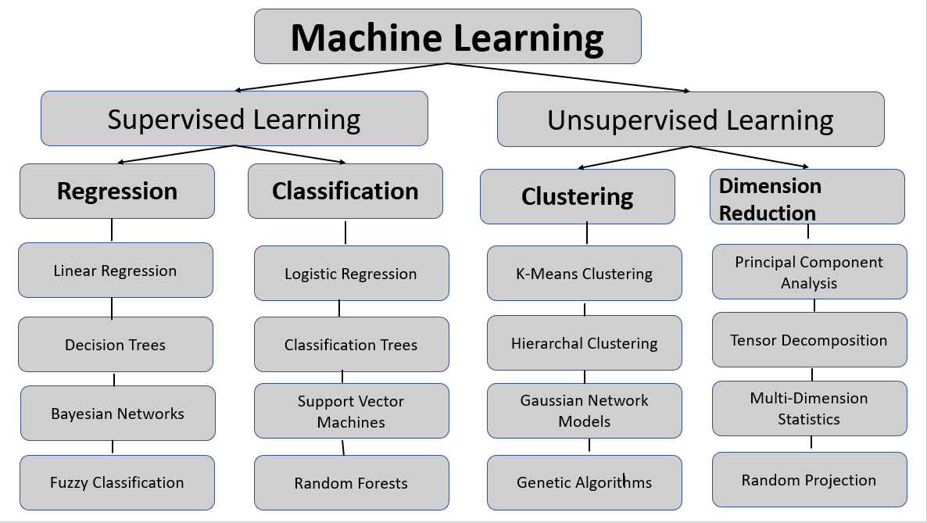
Fig. 1.1 Machine Learning [All the figures should have number and name and it should be mentioned below the figure]

Table 1: Table Name
[All the tables should have number and name and it should be mentioned above the table]

References (Follow this format and include minimum 10 to 12 references. It should be journal only)

[1] Edmonds, J. and Karp, R.M., 1972. Theoretical improvements in algorithmic efficiency for network flow problems. Journal of the ACM (JACM), 19(2), pp.248-264.
[2] Ray, S., 2019, February. A quick review of machine learning algorithms. In 2019 International conference on machine learning, big data, cloud and parallel computing (COMITCon) (pp. 35-39). IEEE.

